**Create a simple soapUI project:**

**We have an online WebService for Breeze Trade, there is a service named “About”.**

**Path: https://218.189.41.115:443/bsoi/services/about/version (need internet)**

**Let’s create soapUI script for this webservice.**

1. Right click Projects node to create a new sopaUI project.



Project Name: first project

1. Right click to add a WADL

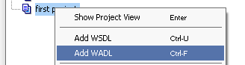

WADL Location: /bsoi/services

1. Change Name to BSOI, change Base Path to /bsoi/services 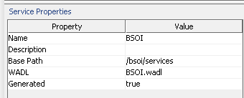
2. Right click BSOI to create New Resource

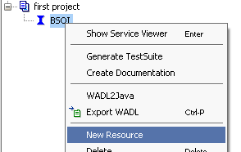

Resource Name: about

Resource Path/Endpoint: /about



Then cancel, no need to create method for about.

1. Right click about to create New ChildResource

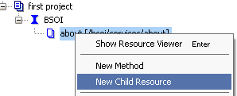

Resource Name: version

Resource path/Endpoint: /version

Then create method

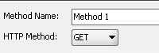

1. Right click first project node to create TestSuite

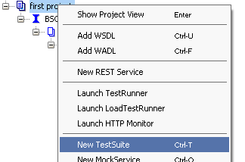

Specify name of TestSuite: test version WS

1. Right click test version WS to create New TestCase

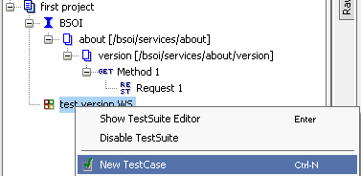

1. Right click

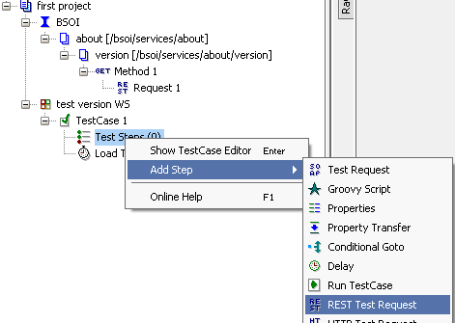

Specify name for new step: version

1. Select REST method to invoke for request : BSOI->/version->method1->Request1

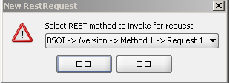

1. Double click BSOI node and click “Service Endpoints” tab

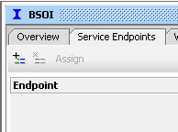

1. Click to add a new endpoint

Enter new endpoint URL: [**https://218.189.41.115:443**](https://218.189.41.115:443)

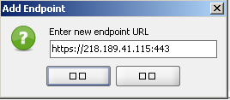

1. Double click version Request and select the endpoint for it

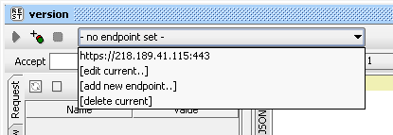

1. Click to run this request.
2. Results are:

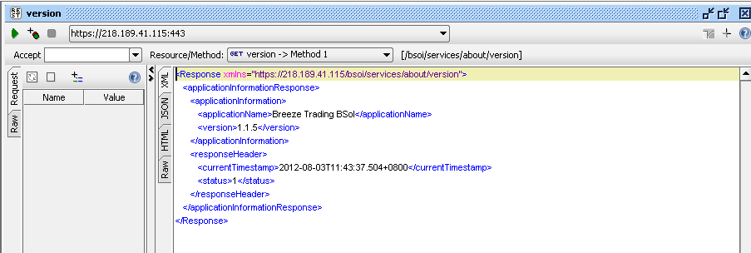

1. Enhance the script- add assertion
2. Click  to add assertion
3. Such as Contains assertion

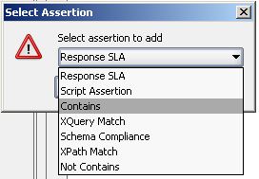

Content: Breeze Trading BSoI2

1. You can see assertion failed

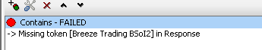

1. Change contain assertion to “Breeze Trading BSoI”
2. You can see assertion success

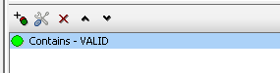

Green signal means assertion success.

*END*